.

Receptionist Admin Portal

User Manual

Version 0.1

02/05/2021

Table of Content

1. Introduction 1

2. Overview 2

2.1. Receptionist App supports following features: 2

2.2. Architecture of system 2

2.3. User access mode 2

3. Getting Started 3

3.1. Set-up Considerations 3

3.2. Accessing the System 3

3.3. Service flow 3

3.1.1. Check in flow 3

4. Using the System 10

4.1. Visiting reason selection 10

4.2. Visited contact selection 11

4.3. Visitor information collection 14

4.4. Sign the security terms and conditions 16

4.5. Badge generation 18

4.6. Scan QR code 19

4.7. Delivery and deposit a document 20

5. Appendix A: Record of Changes 22

# Introduction

Receptionist Application is a modern visit management tool which is used at the front desk of a company or an organization to facilitate receptionists to deal with daily routines of check-in and check-out of visitors.

The admin portal is a management application for Receptionist Application. On this portal, employees of the company can manage their visits.

# Overview

## Receptionist Admin user roles

Who will use this portal? There are 3 different roles of the users, and each kind of role can have different management features.

Table 2 – parameter to input

|  |  |
| --- | --- |
| **Roles** | **Features** |
| Common Employee | Manage personal information  Manage personal contacts  Manage personal visits |
| Receptionist | Manage active visits  Has full privilege of Common Employee |
| Admin | Manage employee information  Has full privileges of Receptionist and Common Employee |

Each user of the portal will be allocated a role to him when his account is created. When the user is logged in, he can manage his service within the limitation of his role.

## Receptionist Admin portal supports following features:

* Login and logout.
* Personal information management.
* Personal visit management
* Personal contacts management
* Active visit management.
* Employee (User) management

## Architecture of system

* Receptionist Admin Portal(RAP) utilizes a browser-server based architecture.The backend server contains a web server and database. The web server is built with express on node.js. The database where the system data and service data are stored, is a Mongo DB. The DB can be a local installed database server or you can use a clouded based DBaaS.

## User access mode

* RAP is a web-based application, user can access it through web browser. Type in the url of portal, then he can access the portal.

# Using the System

This chapter demonstrates detailed operation of Receptionist Admin portal.

## Login to the portal

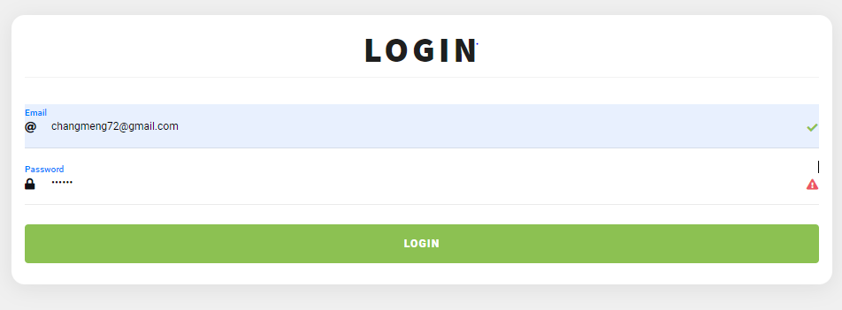

Figure 5 Visit reason selection page

The first step to use the portal is to login into the portal. Only user with a valid account in the RAP can login to the portal. User should input his email address which registered in his account , and password to login into system.

## Main page

When user has successfully logged into portal, he will see the main page:

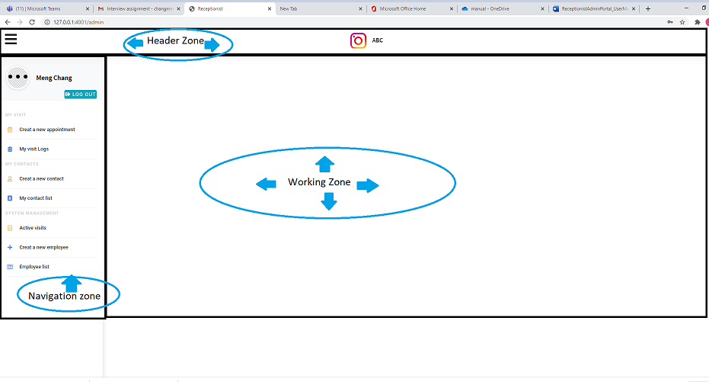

Figure 6 Contact selection page

This page contains 3 zones:

Navigation zone, there is a menu of different management features. User can select management functions from here.

Header zone, currently it’s fixed layout part, shows company logo, and a menu trigger button at the leftmost.

Working zone, where the specific functions user choose is operated at this zone.

## Personal visit management

### 3.3.1. Create a new appointment

User can create a new appointment for himself on the portal by click ‘Create a new appointment’ menu item at Navigation zone.

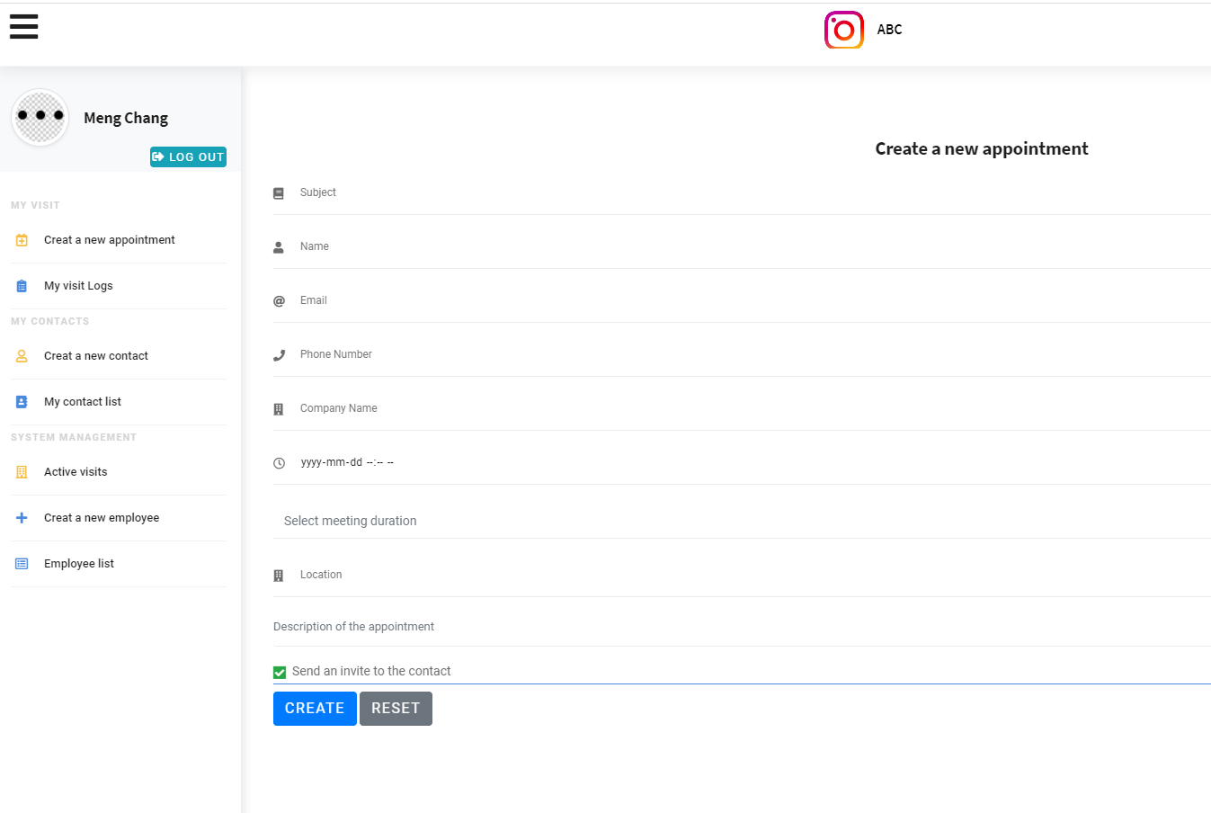

Table 2 – parameter to input

|  |  |
| --- | --- |
| **Visiting reason** | **Description** |
| Subject | The subject of the appointment |
| Name | The name of the invitee.  This is a part of personal contact information of the invitee.  It’s a mandatory parameter. |
| Email | The email address of the invitee  This is a part of personal contact information of the invitee.  Email is mandatory if user want to send an invitation email to the invitee. |
| Phone Number | The Phone number of the invitee  This is a part of personal contact information of the invitee. |
| Company Name | The company name of the invitee  This is a part of personal contact information of the invitee.  This is a part of personal contact information of the invitee. |
| Appoint date and time | The date and time arranged for the appointment.  This is a mandatory parameter. |
| Forecasted duration | The expected duration of the appointment |
| Appoint location | The proposed location of the appointment. The user can input the specific floor and room for the appointment. |
| Description of the appointment | This a customized description of the appointment. User can input more detail about the appointment |
| Send an invitation to the contact | This is a option checked default. If user check this option, the portal will automatically send an invitation to the invitee after creation. |

After user input all the information about appointment, the portal will create an appointment in the backend, and send a email of invitation to the invitee.

If the creation is successful, user will get a confirmation popup. The flow is finished after the user press ‘OK’ on the popup.

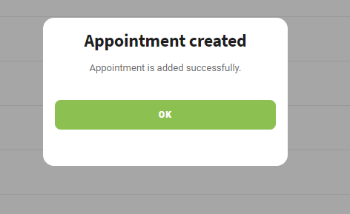

### 

An QR code with appointment information is included in the email to the invitee. This QR code could be used at check in stage when the invitee arrives the front desk. More detail about preregistered visit can refer to <Receptionist Application Manual>.

### 3.3.2. Manage own visit

All historical appointment information are stored in the backend , and a user can manage his own appointments by press ‘My visit log’ item at Navigation zone:

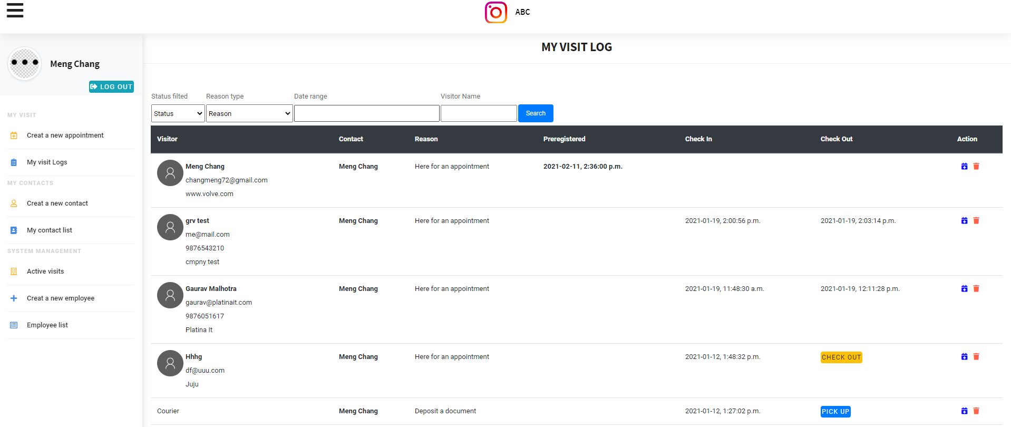

Figure 8 visitor contact information collection page

User can see the logs of all of his appointments at working zone.

The parameters of the visit log including:

|  |  |
| --- | --- |
| **Visiting reason** | **Description** |
| Visitor Information | The contact information of the contact: Name, email, phone number and company name. |
| Contact | Here is the name of the user. |
| Visiting reason | Here for an appointment/ Delivery / Deposit a Document |
| Preregistered | If this appointment is created by the user himself, then there is the data and time of the creation. |
| Check in | The data and time when visitor checked in to office |
| Check out | If the visitor is checked in and not checked out, user can press Yellow button ‘checkout’ to check the user out manually.  If the visitor is a courier, use can press blue button ‘Pickup’ to indicate he has fetched the delivery    If the visitor has checkout, the data and time of check out is shown here. |
| Action | User can manage his visit here. Two actions are provided for user for each specific visit:  Delete: User can delete a visit record from his log;  Create a new appointment: This a shortcut to create a new appointment. The information of the invitee of current appointment can be used in the new appointment creation. This feature facilitates user to reinvite one for a new appointment. |

#### 3.3.2.1 Visit search

User can input search condition to filter the visit log:

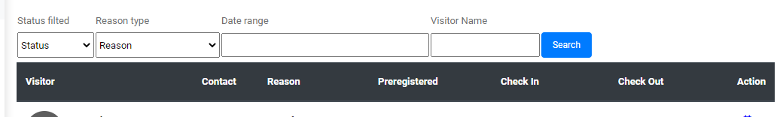

Figure 9 visitor contact information collection page

|  |  |
| --- | --- |
| **Search condition** | **Description** |
| Status filtered | There are 3 visit status can be used to filter visit:  Checked in: to search all visit now the visitor has checked in  Checked out: to search all visits now the visitor has checked out  Preregistered: to search all visits preregistered and now the visitor has not checked in. |
| Reason type | The visit reasons: Here is an appointment, Delivery and Deposit a document. |
| Date range | The range of date and time for searching.  Based on the status of visits, the dates and times of visits used for search are different:  If visit status is ‘Preregistered’, then the preregister time is used for matching;  If visit status is ‘Checked in’, then the Checked in time is used for matching;  If visit status is ‘Checked out’, the Checked-out time is used for matching. |
| Visitor name | The full name of the visitor |

## Contact management

RAP provides users with contact management function. User can create/view/delete his contacts.

Now the contact can be used to create new appointment.

### 3.4.1. Create a new Contact

User chooses ‘Create a new contact’ from listed items in the navigation zone to create a new contact:

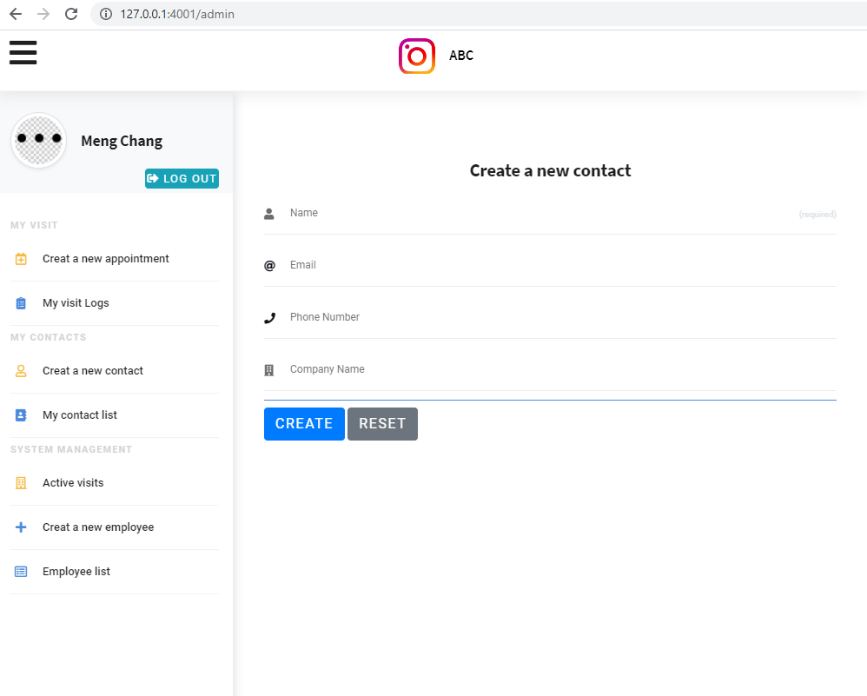

Parameters used to create a new contact

|  |  |  |
| --- | --- | --- |
| **Search condition** | **Description** | **Category** |
| Name | The full name of the contact | Mandatory |
| Email | The email of the contact | Optional |
| Phone number | The phone number of the contact | Optional |
| Company name | The name of the company where the contact serves | Optional |

### 3.4.2. View and management the contacts

User can choose this feature by click ‘My contact list’ . A list of all contacts of the user will be listed at the working zone.

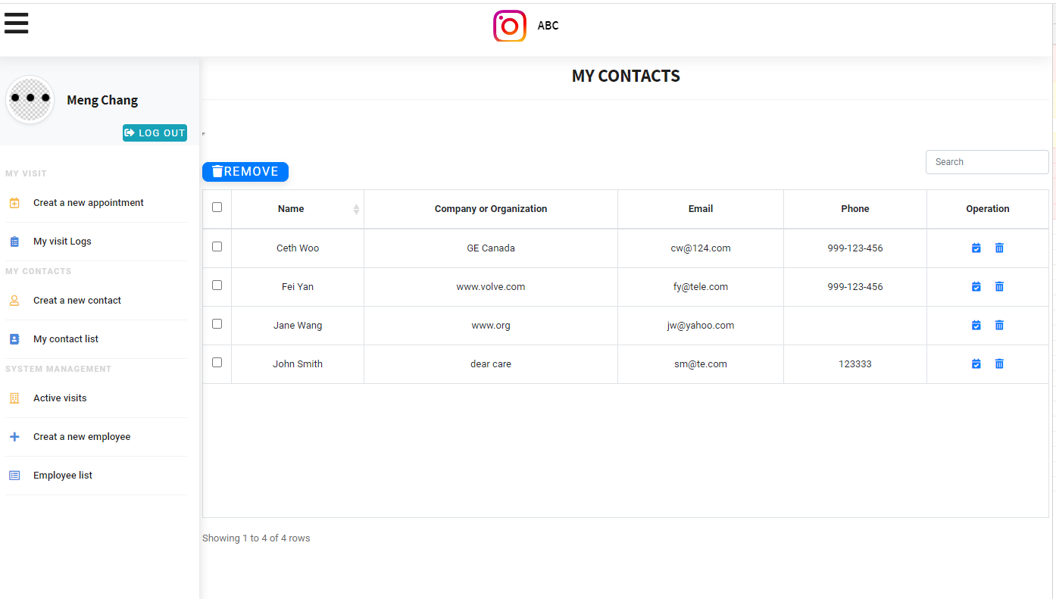

Figure 12 visitor contact information collection page

There are several management functions implemented on this page:

1. Batch removes. User can multiply select contacts from the list ,and press Remove button on the top to batch remove multiple contacts in one operation.
2. For each contact, user can press delete icon at the operation column to delete the contact on the line.
3. For each contact, user can create a new appointment with the selected contact by press ‘new appointment’ icon button in operation column

Figure 15 Badge generation page

## Active visit management

### 3.5.1. Overview of all active visits

This function is provided to receptionists to check all active visits right now. The active visits are the visits in Checked in status.

From this page, receptionist can overview how many visitors are in the office now, and which visit is ongoing:

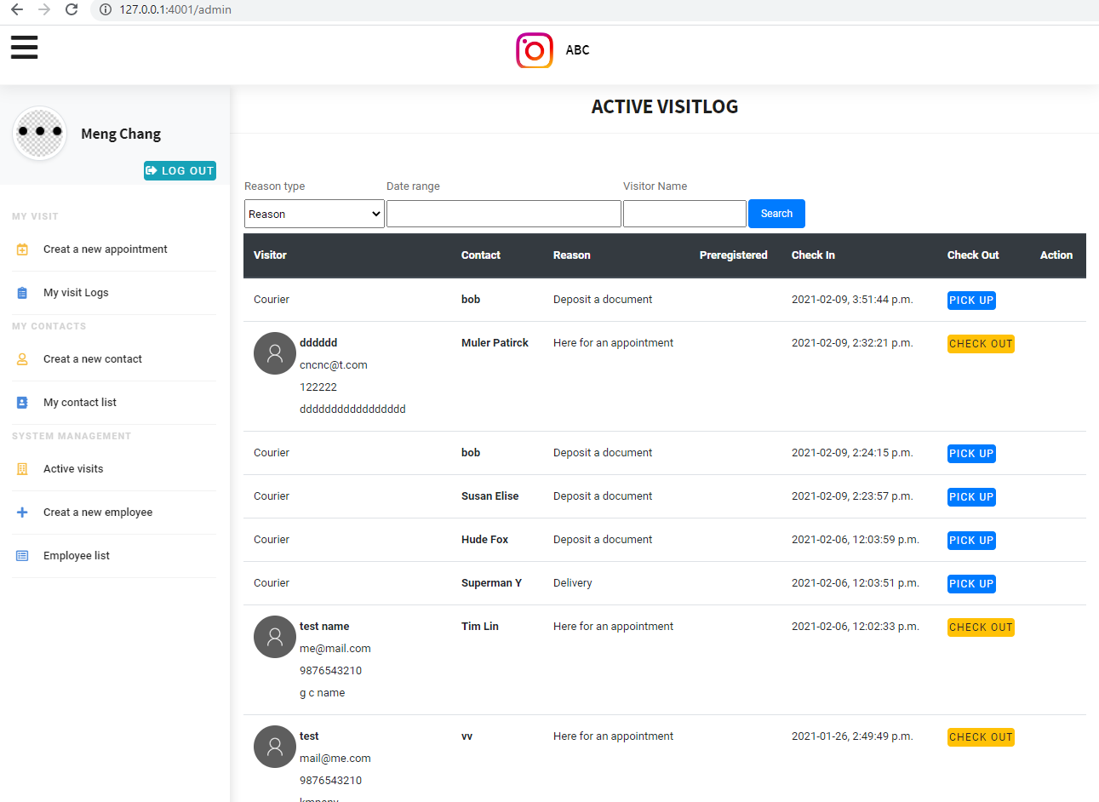

Figure 16 courier visit registered notification page

### 3.5.1. Manually check out

Normally a visitor checks out with scanning his badge. Here a manaully check out function is provided to receptionists. Receptionist can query the visit here and press ‘Check Out’ or ‘Pickup’ button in Checkout column to check the visitor out.

### 3.5.2. Visit search

Receptionists can filter the visit records by following conditions or condition composition:

1. Date and time of the visit
2. Full name of the visitor
3. Visit Reason

## Employee management

This function is provided to admin role to create new account /modify existing account /view /delete .

**3.6.1.** **Create a new Employee**

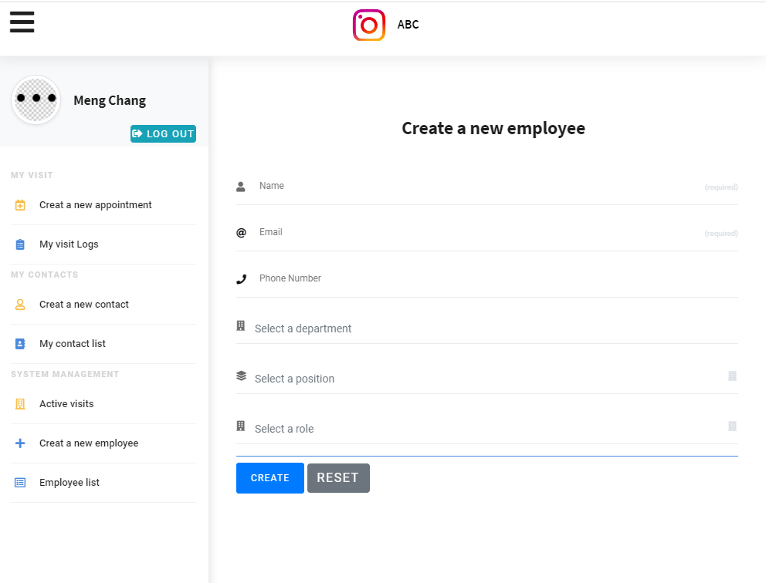

Parameters used to create a new contact

|  |  |  |
| --- | --- | --- |
| **Search condition** | **Description** | **Category** |
| Name | The full name of the new employee | Mandatory |
| Email | The email of the new employee. This field is mandatory, and user will use his email to log into the RAP. | Mandatory |
| Phone number | The phone number of the new employee | Optional |
| Position | The designation of the new employee | Optional |
| Department | The department the new employee belongs to | Optional |
| Role | The role of the new employee. There are 3 kinds of roles in the RPA: Admin, Receptionist and Common Employee. Each role is allocated with different privilege in RPA. | Default value is Common Employee |

After admin press ‘Create’, a new account will be created in the system. And a email with initial login password will be sent to the new created employee.

**3.6.2.** **View employee list**

Admin user has pressed ‘Employee List’, a list of all employees is shown at working zone:

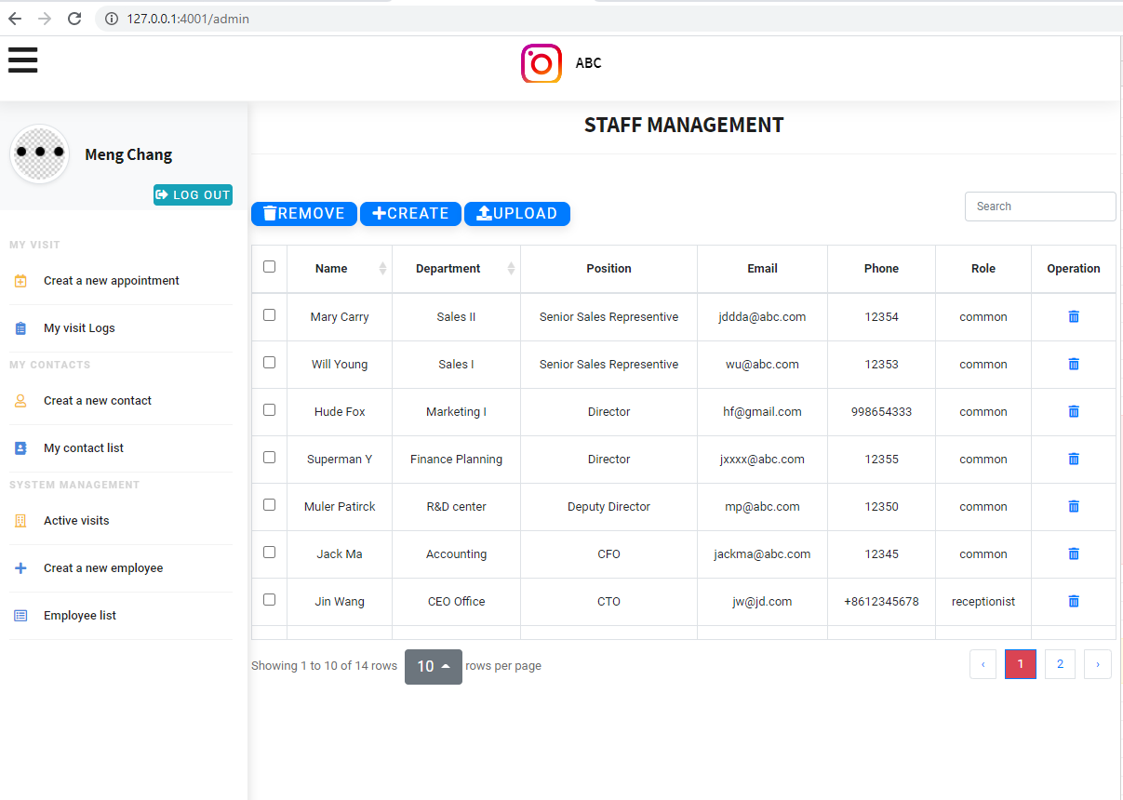

#### **3.6.2.1** **Batch delete**

Admin can multiply select employees from the list, and after that presses ‘Remove’ button on the top to delete multiple employees from system in one operation.

#### **3.6.2.2** **Batch upload**

Admin can batch create employees by uploading a precompiled excel file.

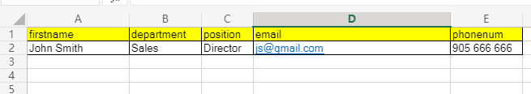

The first line is header ,it’s needed to record column name.

The following lines are employee information used to create new accounts.

**3.6.2.3** **Shortcut to create new Employee account**

Admin can press ‘Create’ to jump to 3.6.1 create a new employee page to create a new employee.

**3.6.2.4** **delete an employee account**

Admin can press ‘delete’ icon button in the ‘Operation’ to delete the account on the line.

# Appendix A: Record of Changes

Table 4 - Record of Changes

| **VersionNumber** | **Date** | **Author/Owner** | **Description of Change** |
| --- | --- | --- | --- |
| **0.1** | **02/08/2021** | **Meng Chang** | **Receptionist App User Manual** |
|  |  |  |  |